BUG REPORT OF DROOM
APP: DROOM
DEVICE : OPPO A37F
ANDROID VERSION : 5.1.1
APP VERSION: 2.32.5
DOWNLOAD SIZE : 14.31 MB
[PORTRAIT MODE]
1.MODULE/PATH : Homepage
BUG : In home page “MY REQUIREMENTS” not written in straight line.
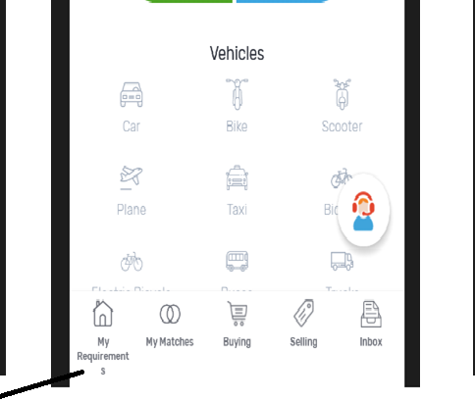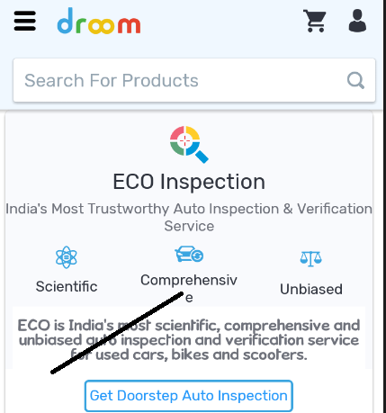
EXPECTED RESULT : “MY REQUIREMENTS” should written in straight line.
PRIORITY : Law
2.MODULE/PATH : Forgot password
Bug : Unregistered email-id valid.
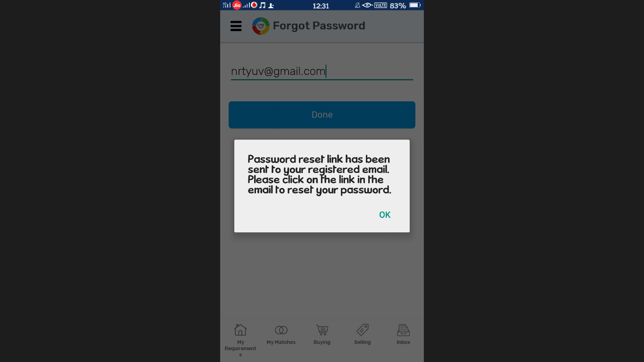
EXPECTED RESULT : Registered email-id should valid.
PRIORITY : High
3.MODULE : DROOM ASSIST
BUG : Module name does not show properly.

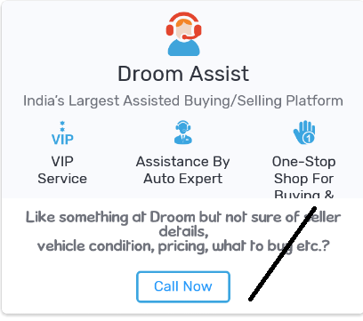
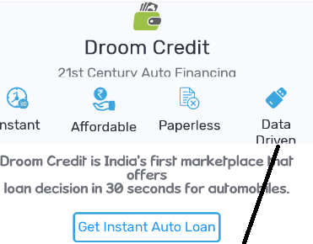
EXPECTED RESULT : Module name should show properly.
PRIORITY : Medium
4.MODULE : INBOX
BUG: Scrolling function is not working at buying module.

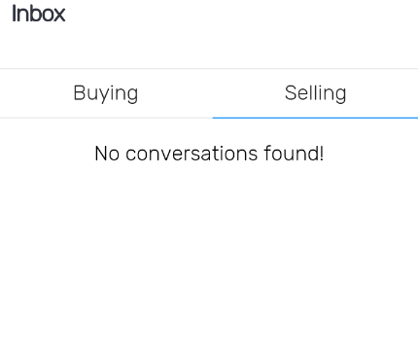
EXPECTED RESULT : Scrolling function should working at buying module.
PRIORITY : Medium
5. MODULE : SELLING
BUG : There is no validation message fired while no data awailable at selling module.
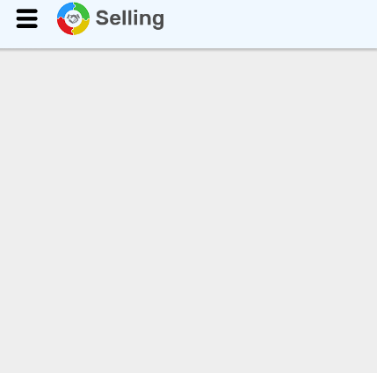
EXPECTED RESULT : Validation message should fired.
PRIORITY : Medium
6.MODULE: TRACTOR
BUG : System does not show any features in used model.
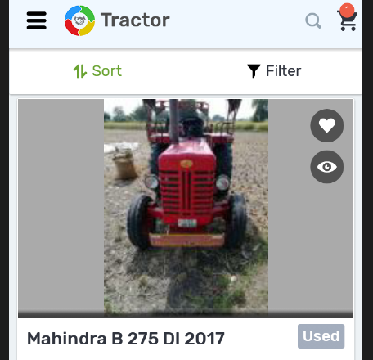
EXPECTED RESULT : System should show any features in used model.
PRIORITY : High
7.MODULE : WARRANTY
BUG : Deasign is not proper.
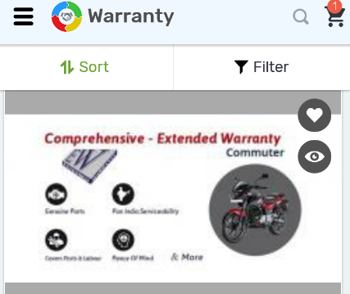
EXPECTED RESULT : Design should be proper.
PRIORITY: Medium
8.MODULE : INSPECTION CERTIFICATE AND PRICING CERTIFICATE
BUG : Same data dislay by system for INSPECTION CERTIFICATE AND PRICING CERTIFICATE



EXPECTED RESULT : Do not display same data.
PRIORITY : Medium
9.MODULE: PREMIUM SERVICES
BUG : In pro-seller premium subscription , system is not fired any message when no data awailable there.

EXPECTED RESULT : In pro-seller premium subscription , system should fired any message when no data awailable there.
PRIORITY : Law
10.MODULE :CREATE ACCOUNT
BUG : In valid mobile format allow.
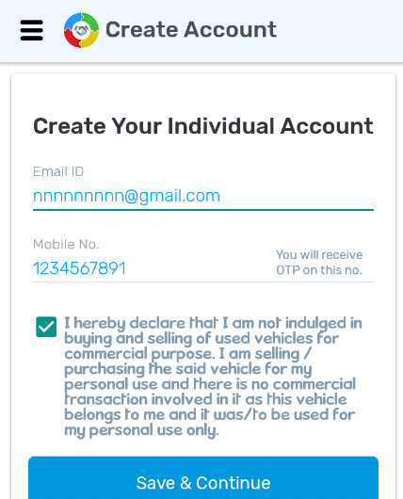
EXPECTED RESULT : In valid mobile format does not allow.
PRIORITY :High
[SUGGESTIONS]
1.In profile image should have photo remove option.
